# Lesson 1 What is computer science?

## Learning objectives

1. Learn something about one another.
2. Get excited about what we’ll be learning in this course.
3. Describe our class policies on homework, absences, late work, academic integrity and digital citizenship.
4. Get familiar with the course web site.
5. Explain the role that algorithms play in developing solutions to computer science problems.
6. Explain why computer science is more than just computer programming.

## Homework

1. Get a 3-ring binder, divide it into 8 sections labeled Units 1-8, and fill each section with paper.
2. Have a parent sign your Course Info Letter.
3. Write me a 1-page letter telling me anything you’d like me to know about you. Turn it in through Edmodo as an attachment.

## Agenda

1. Introducing ourselves – 10 min
2. Mini-lesson: the world of computer science – 15 min
3. Class policies – 10 min
4. Logging in – 5 min
5. Course folders and the course website, Edmodo – 15 min
6. **(If time permits)** Research activity: Definitions of CS on the web – 10 min
7. Start HW #1 – 10 min

### Introducing ourselves

Have each student stand up and state

* First name
* Where you were born
* A talent you have that not many people know about (video games don’t count)

### Mini-lesson on the world of computer science

*“Computer science is no more about computers than astronomy is about telescopes.”* Edsger Dijkstra

“What does Prof. Dijkstra mean by this?” Take up a few responses.

Develop these diagrams, generally moving from left to right.

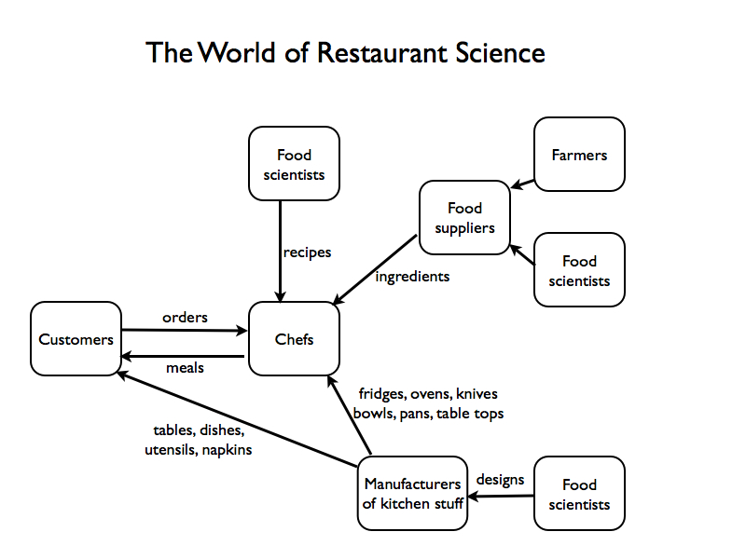

*Is restaurant science simply about how to operate ovens and kitchens? No.*

*Is restaurant science simply about how to cook? No.*

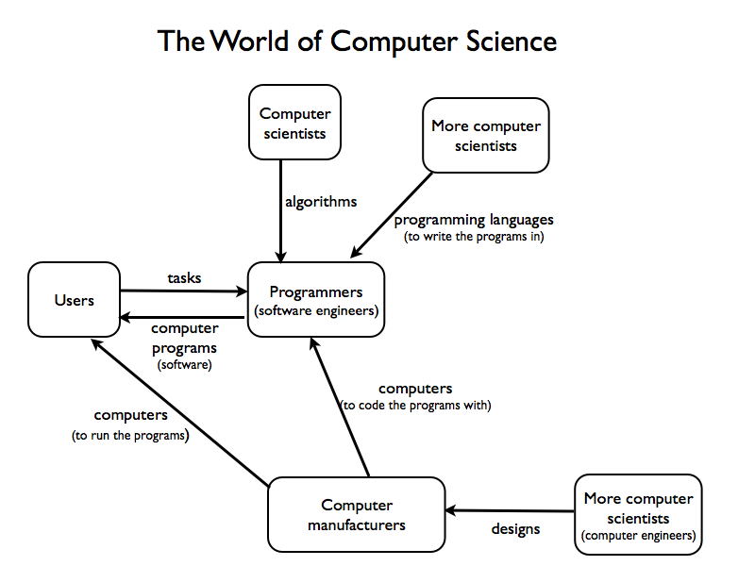

*Is CS simply the study of computers? No.*

*Is CS simply about how to write programs? No.*

*Can you invent a recipe without making it in the kitchen first?* Yes!

*Can you invent an algorithm without using a computer?* Yes!

*Can you tell if a recipe will be good or bad before you actually make it in the kitchen?*

Sometimes. Though testing helps a lot.

*Can you tell if an algorithm will work before you actually program it on a computer?*

Yes! There are entire CS courses devoted to this skill. Design of Algorithms

In ICS3UI, we will touch on all of these areas of CS, but our main focus will be on how to design good algorithms, program them, and test them. We’ll spend a short time learning how computers work.

### Class policies

Have kids come up and get a course info letter and read it silently to themselves.

Have them mark each sentence in the letter with a

* **check mark** if that policy makes sense to them
* **frown face** if they don’t like that policy
* **question mark** if they have a question about that policy

Take up frowns or questions.

(*Optional*) If time and mood permit, present the **Tree of Respect**.

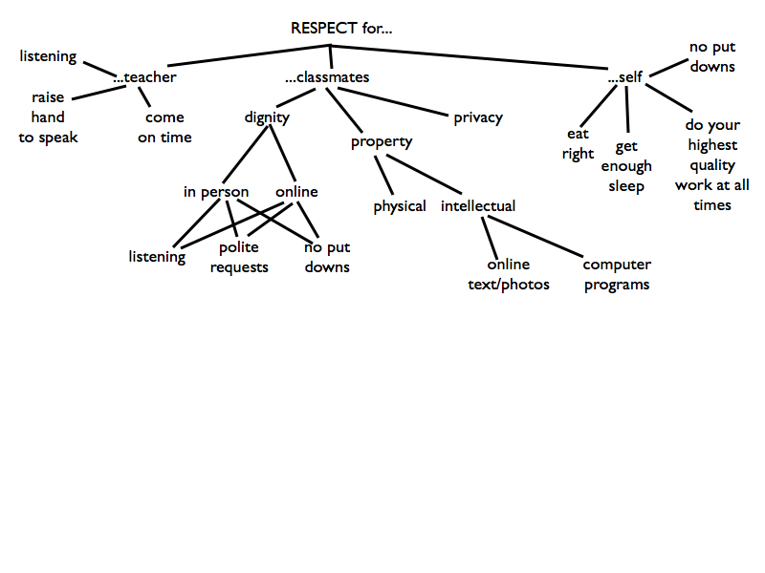

### Log in and course web site

Have kids log in to computers and find ICS3UI/Unit 1/Lesson 1 folder.

Have them open *Edmodo Scavenger Hunt.doc* and get acclimated to Edmodo at their own pace.

When done, have them start the letter-writing portion of HW#1.